**Mission 3:**

**Light Show**

**Student Workbook**





**Welcome back!**

This mission will explore the colorful lights at the top of the CodeX. You will learn how light can make all the colors you see.

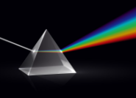

Go to the Mission 3 Log and fill out the Pre-Mission preparation.

**Mission 3: Light Show**

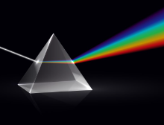

The CodeX has 10 LEDs (little lights). Four of the lights are Smart RGB LEDs -- also called pixel LEDs.

* What is a Smart RGB LED (pixel LED)?
* With only three colors -- **red**, **green** and **blue** -- the LED can display any color
* Click on  to add it to your toolbox.
* Watch the video on pixels:   
  [[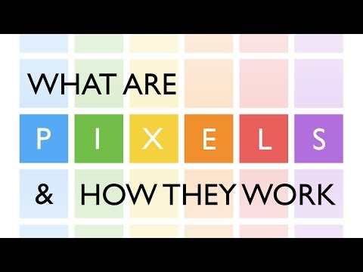](https://www.youtube.com/embed/m8c1CAT2zEI?feature=oembed)](https://youtu.be/m8c1CAT2zEI)

**Mission 3: Get started**

* Go to <https://make.firialabs.com/> and log in.



* Click and start Mission 3.

**Objective #1: Find the pixels**

The CodeX has four Red, Green, Blue (RGB) LEDs along the top. These are the Smart RGB LEDs, or pixel LEDs.

* You can set these LEDs to any color under the sun.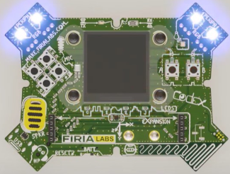

The CodeX library gives you some built-in colors to use:

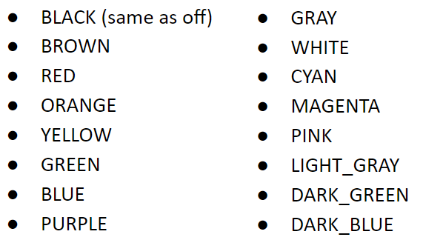

**Objective #1: Find the pixels**

**DO THIS:**

* Close the instruction panel
* Use the camera controls to rotate CodeX
* Click on pixel 0 (the first pixel LED)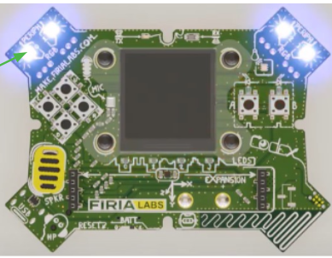

**DO THIS:**

* Create a new file named **Pixels1**
* Click the **File** menu button
* Select “New File…”
* Name the file **Pixels1**
  + *no spaces in a file name*
* Click **Create**

**Objective #2: Turn on the red light**

In Python, use the function:   
**pixels.set(number, color)**   
to turn on a pixel LED

* The function takes two inputs, called **arguments**

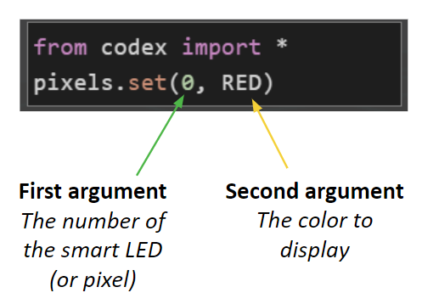

**DO THIS:**

* Click on CodeTrek (same code as above)
* Type the code into your new file
* Run the code
* Change the code to display a different color (use from the list above)

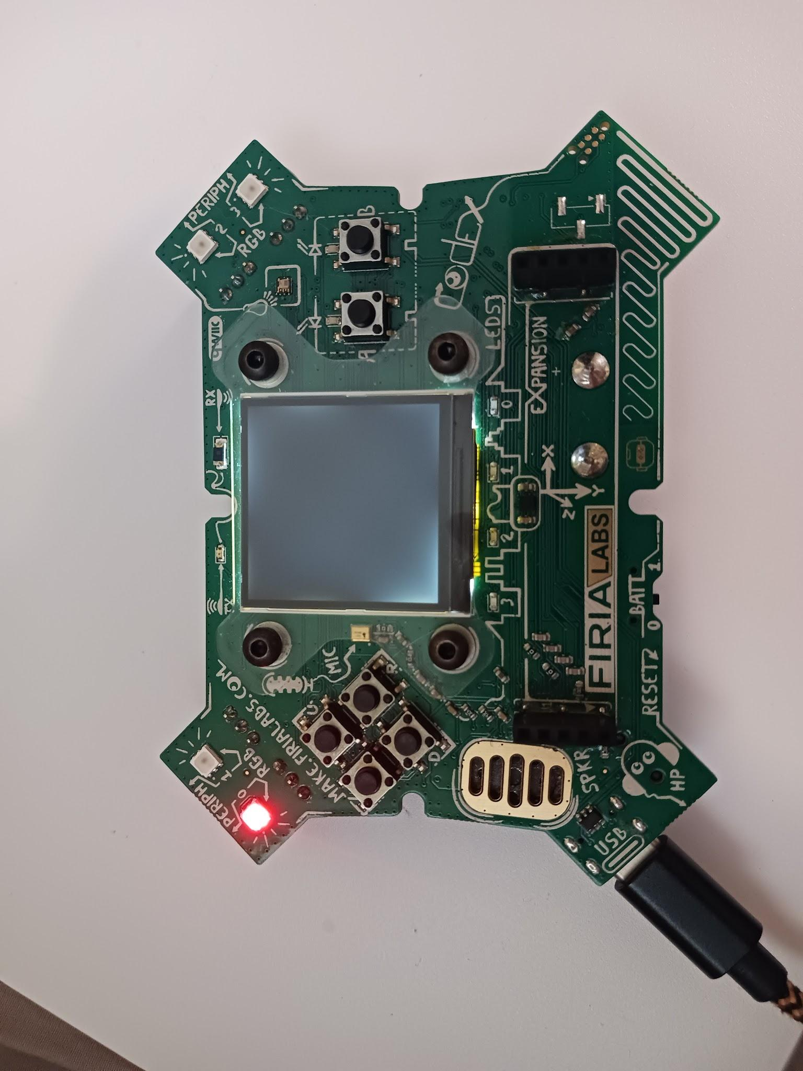

**Objective #3: Two in a row**

Now display two colors in sequence.

* **Sequence** means “go in order, one line at a time”
* But computers are very fast!

**DO THIS:**

Using only pixel 0, turn it RED and then GREEN

* The **Pixels1** code turns pixel 0 to RED
* Add another line of code (line 3) that will turn pixel 0 to GREEN
* Did you see both colors?

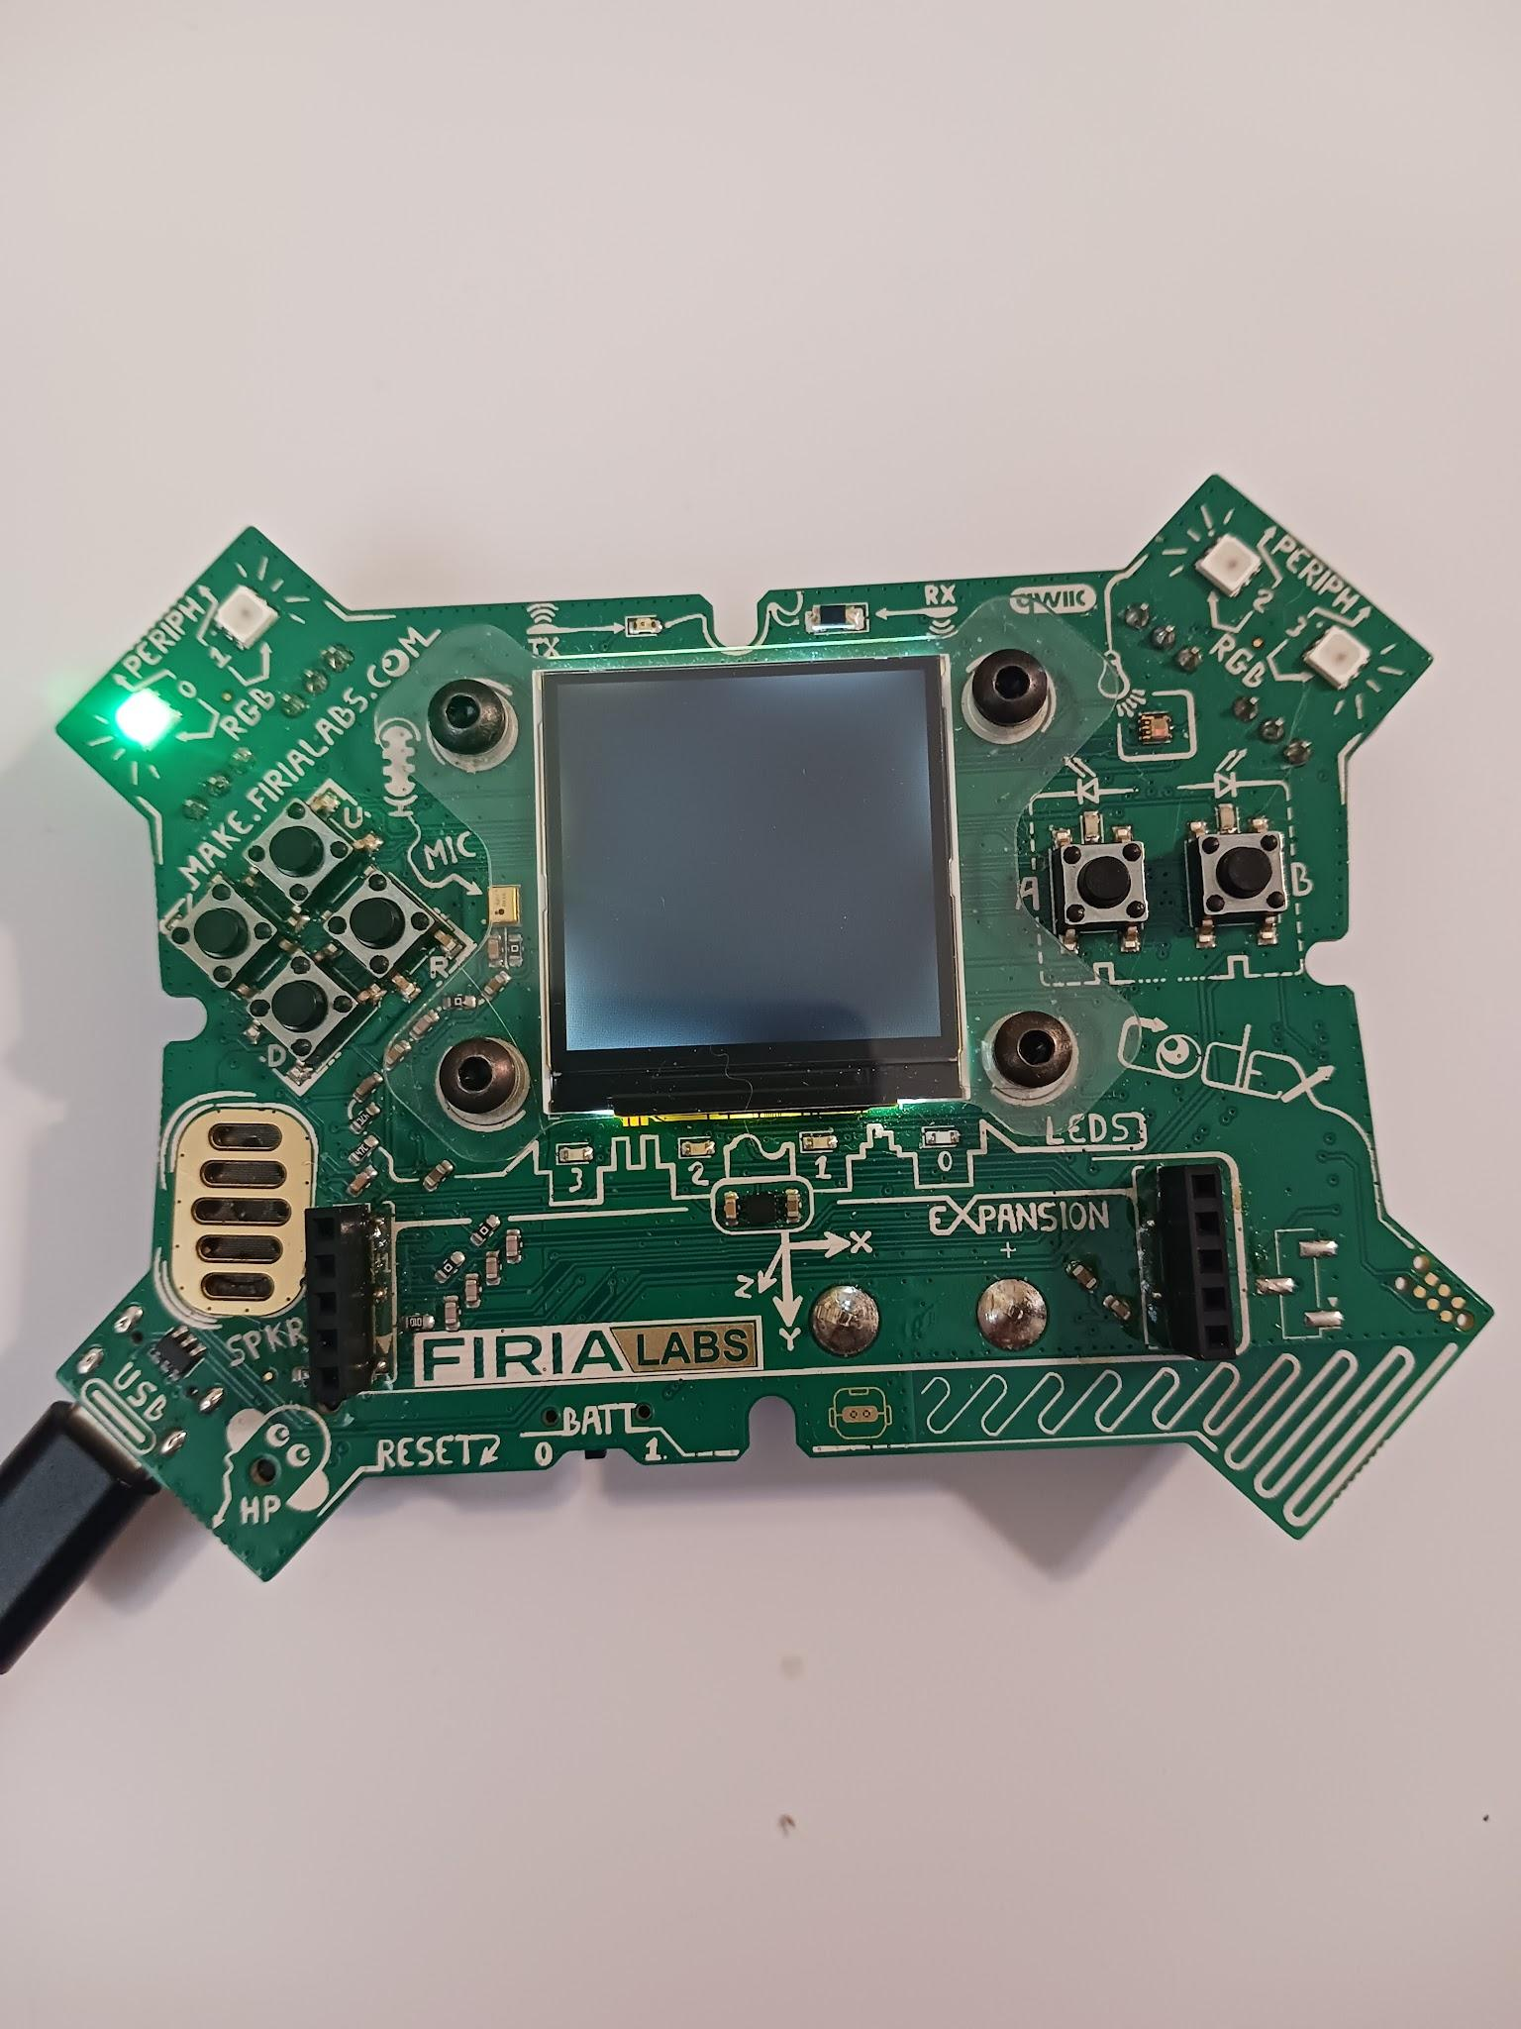

**Objective #4: What’s going on?**

Why is only the last color showing?

* Did you notice the program ends very quickly?
* It doesn’t wait for you to see the first color before it displays the second color
* And the last color stays on even after the program ends



**DO THIS:**

Add more colors to your code. Using only pixel 0, change it to four different colors.

* Add two more lines of code to **Pixels1**
* Line 4 -- change to BLUE
* Line 5 -- change to WHITE
* Before you run your code, predict what will happen.
* Write your prediction in the Mission Log
  + - * Run your code



**Mission Quiz**

Test your skills by **taking the quiz**.

**Objective #5: Find the bug**

Inside the mind of a computer

Computers are fast. Even a small computer like the CodeX can execute *millions* of operations per second!

CodeSpace includes an important tool called the “debugger”. It slows down the program execution and lets you see the code running sequentially -- one line at a time.



**DO THIS:**

* Click on  to add it to your toolbox
* Write the definition of ‘bug’ in your Mission Log
* Watch the debug video in the instruction panel
* Answer the question in your Mission Log
* Click on the debug button

**Objective #6: Step by step colors**

Your turn to use the debugger

* You can execute, or run, one line at a time using the   
  “Step In” button, which is part of the debugger.
* **Remember:** The code is run AFTER the line is highlighted.
* 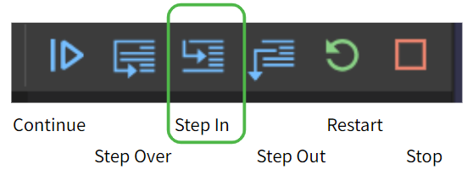
* 

**DO THIS:**

Try stepping through your code

* Click the debug icon
* Click the **Step In** icon
* Slowly click the **Step In** icon several more times, observing what happens after each click
* Now do you see all four colors?

**Objective #7: Slow it down**

When you *step slowly* through the code, all the colors show.

* You just need a way to delay the computer a little after it shows each color
* The **time module** has a **sleep()** function that will pause program execution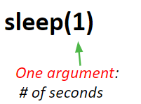
* **sleep(1)** will delay (or pause) the program for 1 second



**DO THIS:**

Update your code

* Click on  to add it to the toolbox
* Open CodeTrek
* Change your code to look like the code in CodeTrek
* **Remember:** type the actual **sleep(1)** command for line 9, not the **#TODO** comment
* Run your code

**Objective #8: Name that number**

It would be fun to play with some different delay times.

* Right now the number 1 appears *three* times in the code
* If you want to change the pause shorter or longer, you would need to change 1 three times
* This number is called a **‘literal’**

Instead of repeating a ***literal number*** like 1 in your code, you can use a name instead.

* A **variable** is a **name** you can give to data
* Data can be a number, a color, an image, or even words (called strings)
* The **variable name** describes the data
* A **variable** is defined before it is used in code

Once a **variable** is defined, it can be used instead of a **literal**. Then if you want to change the value, you only have to change it once.

Examples of **defining variables**:

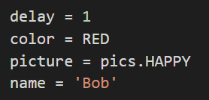

**Objective #8: Name that number**

**DO THIS:**

Learn more about variables

* Click on  to add it to the toolbox
* Answer the Mission Log questions

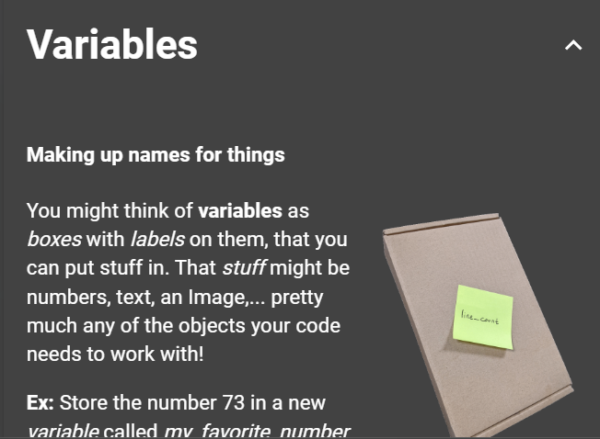

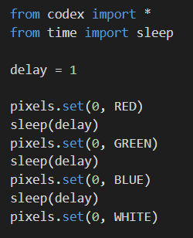**DO THIS:**

Update your code

* Open CodeTrek and use it to help you modify your code
* Define a **variable** called ***delay***
* Use ***delay*** in the sleep() functions
* Run your code
* Did you see all four colors?

**Mission Quiz**

Test your skills by **taking the quiz**.

**Objective #9: Warning sign**

Time to light up all four pixel LEDs 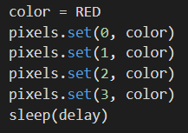

* You can use **pixels.set()** to light up all four pixels
* Just change the **argument** for the pixel number
* You can use a **variable** for the color **argument**

**Time to light up all four pixel LEDs** 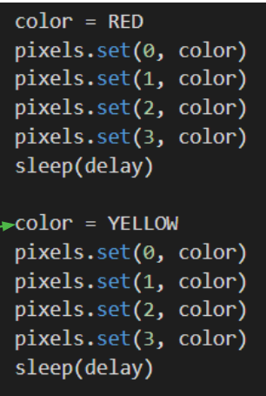

* You can change the value of a variable any time in the code
* This example shows changing the value of color
* You can also change the value of delay if you want to

**Objective #9: Warning sign**

**DO THIS:**

* Create a second variable for **color**
* Set the color to RED
* Use the **color** variable in **pixels.set()** to turn all four pixels the same color
* Change the **color** and turn all four pixels a second color
* Use CodeTrek if you need help
* Run your code
* **Optional:** repeat the code between RED and YELLOW again to make a flashing warning sign

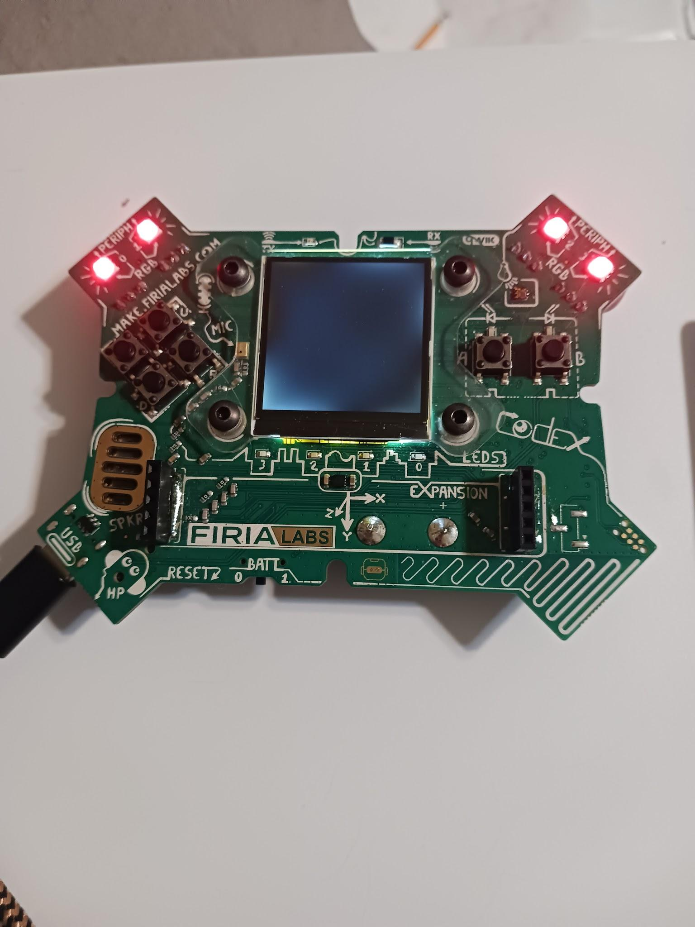

Objective #9 is complete!

**Mission Complete**

You have completed the third mission. 

**Do this:**

* Read your “Completed Mission” message
* Complete your Mission 3 Log
  + Post-Mission Reflection
* Get ready for your next mission!

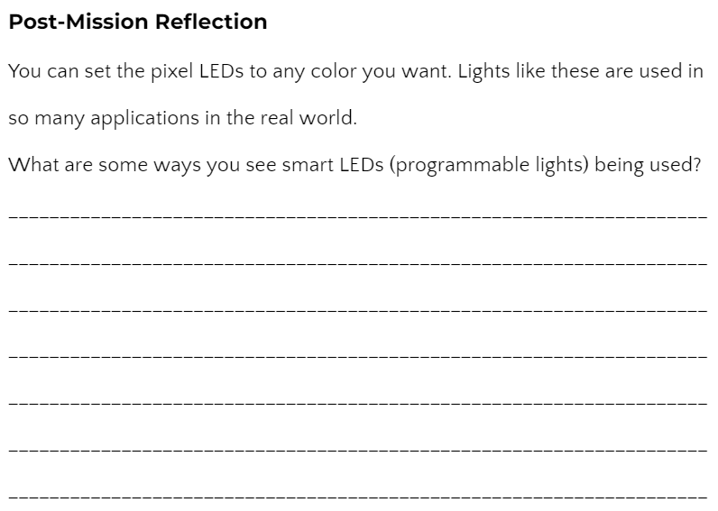

**Wait! Before you go …**

The need for clearing the CodeX

**The need for clearing the CodeX**

* Every time you run your program, it is loaded onto the CodeX
* The last program run stays on the CodeX, even after it is unplugged from the computer
* So you want the last program run to be something that clears the CodeX and isn’t an assignment

**Create a “Clear” file**

* Create a new file called **Clear**
* Type these two lines of code:

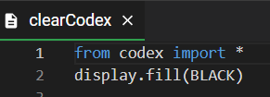

* Run the code
  + The CodeX should be blank, with no pictures or lights on
* Run this code at the end of every class period

**Okay. Now you can go.**